**Metric Beats to Capture Metrics**

* enable nginx metrics
  + navigate to /etc/metricbeat/modules.d and rename nginx.yml.disabled to nginx.yml
  + copy the dashboards into bin sudo cp -r /usr/share/metricbeat/kibana/ /usr/share/metricbeat/bin
  + Now start the metric beat after setting in metricbeat.yml
    - cloud.id
    - cloud.auth
    - kibana url

We have configured all dashboards

System Overview:  
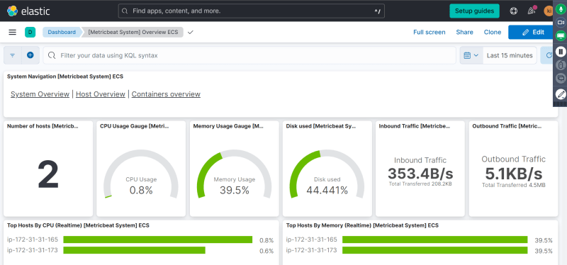

Apache Dashboard  
